To find articles through the CSULB library:

Select Articles from the dropdown menu. Enter the title from the Syllabus Course Schedule. Make sure you spell it correctly.

Step 1:

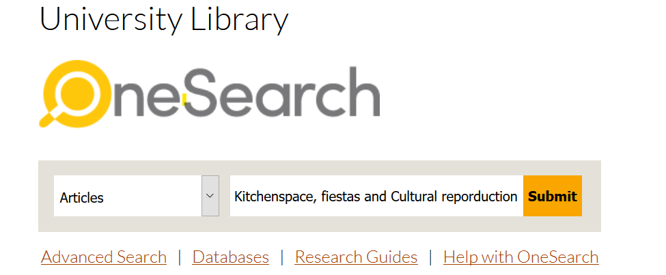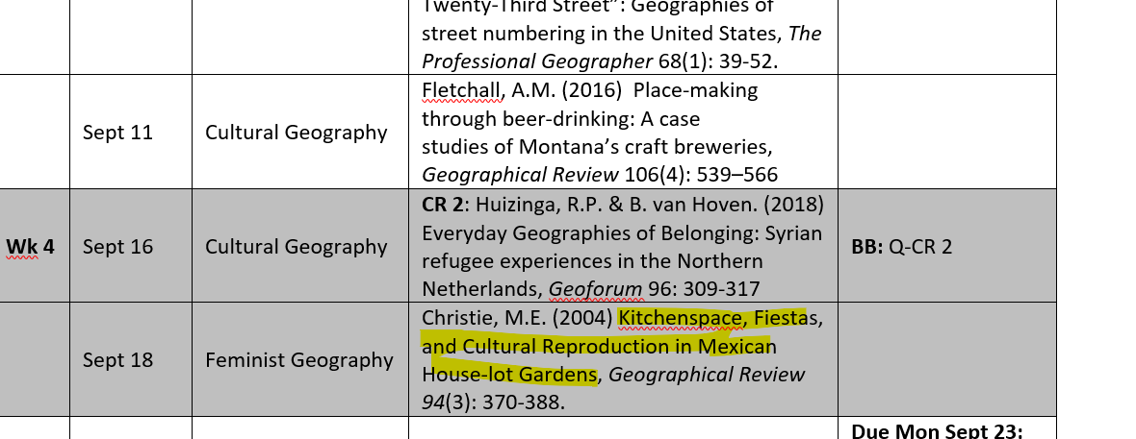

Step 2: Login to your library account using your CSULB ID and password.

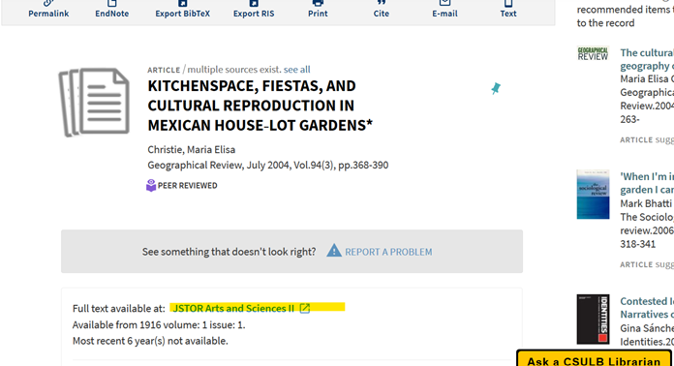

Step 3: Select a database from which the full text is available, such as JSTOR Arts and Sciences II.

Follow the steps to open the article. Every database will have a slightly different look and procedure for downloading. In this case, select the “Download PDF”.

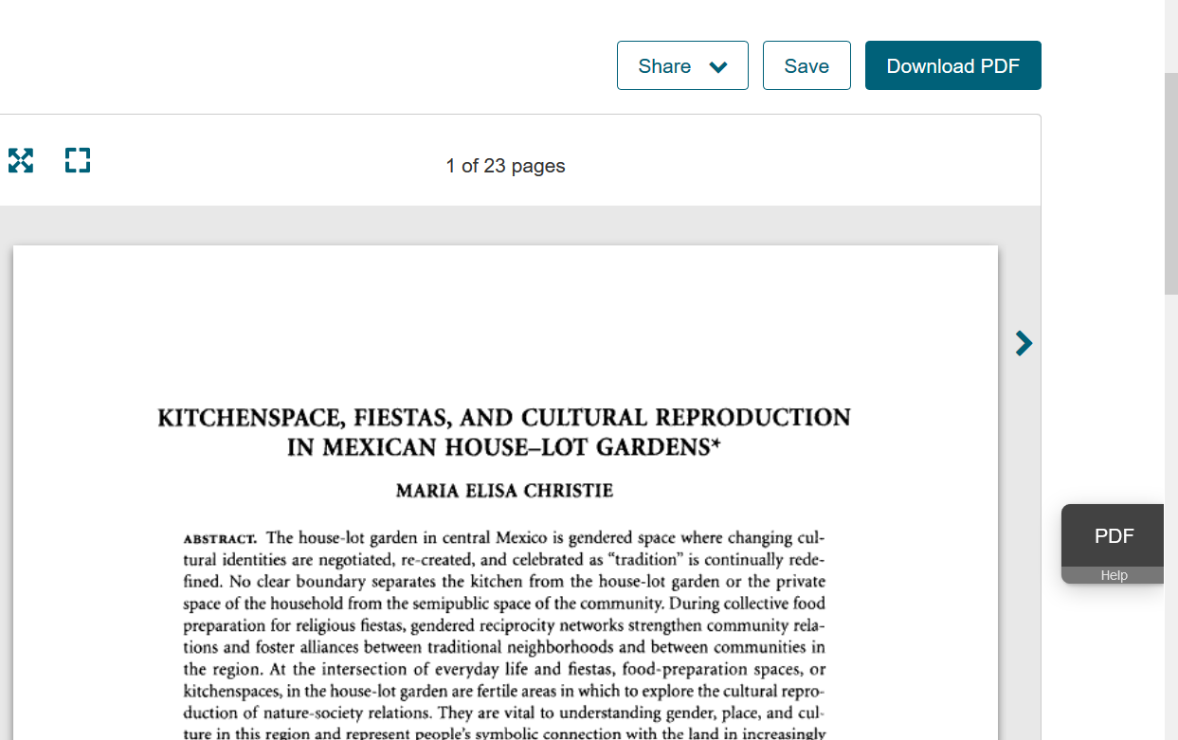

Troubleshooting:

* Try switching to a different browser such as Firefox or Google Chrome.
* Make sure you sign in to your library account.
* Contact the librarian through the “Ask a CSULB librarian” button (see step 2 image, bottom right-hand corner) if you still have issues.